**Zigbee Smart Bulbs** 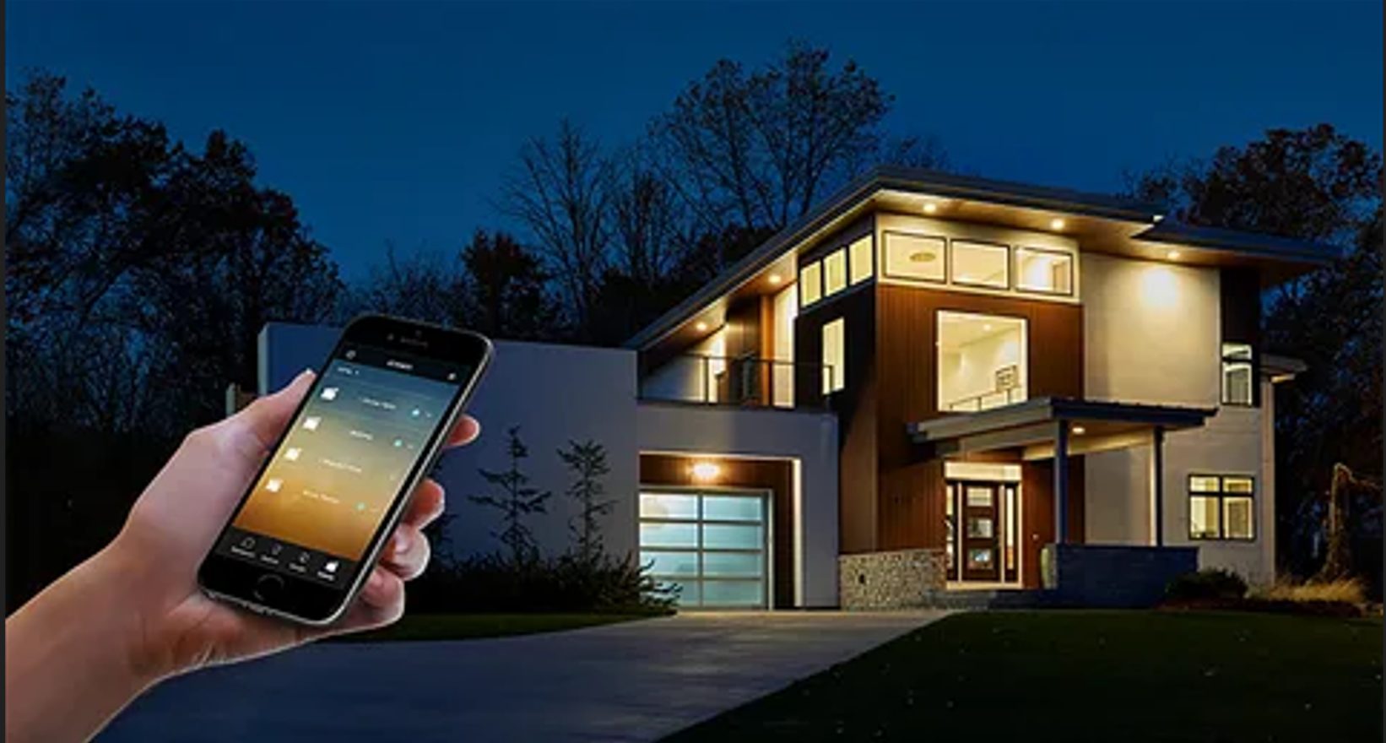

**Description:**

**Zigbee Smart Bulbs** are advanced, energy-efficient lighting solutions that integrate seamlessly with smart home ecosystems. These bulbs use the Zigbee wireless communication protocol, allowing them to connect to a wide range of smart home hubs and devices. With features like dimming, color changing, and scheduling, Zigbee Smart Bulbs offer unparalleled convenience and customization for your home lighting.

* **Technology:** Zigbee wireless protocol.
* **Compatibility:** Works with Amazon Echo (with Zigbee hub), Samsung SmartThings, Philips Hue Bridge, and other Zigbee-compatible hubs.
* **Bulb Type:** A19 (standard bulb shape), E26 base.
* **Wattage:** 9W (equivalent to 60W incandescent).
* **Lumens:** 800 lumens.
* **Color Options:** 16 million colors + adjustable white light (2200K-6500K).
* **Dimmable:** Yes.
* **Lifespan:** 25,000 hours.
* **Energy Efficiency:** Energy Star certified.
* **Control Options:** Mobile app, voice control (Alexa, Google Assistant, Apple HomeKit), and smart home hubs.

**Key Features:**

* **Seamless Integration:** Connects effortlessly with Zigbee-compatible smart home systems.
* **Voice Control:** Control your lights using voice commands via Alexa, Google Assistant, or Apple HomeKit.
* **Customizable Lighting:** Choose from 16 million colors and adjust brightness to create the perfect ambiance.
* **Energy-Efficient:** Uses up to 85% less energy than traditional incandescent bulbs.
* **Scheduling and Automation:** Set schedules, timers, and routines for automated lighting control.
* **Group Control:** Control multiple bulbs simultaneously for synchronized lighting.

**Pricing:**

* **Single Bulb:** $24.99
* **2-Pack:** 44.99(44.99(22.50 per bulb)
* **4-Pack:** 79.99(79.99(20.00 per bulb)

**Where to Use:**

* **Living Rooms:** Create a cozy or vibrant atmosphere with customizable colors.
* **Bedrooms:** Set the perfect lighting for relaxation or wake-up routines.
* **Kitchens:** Brighten up workspaces with adjustable white light.
* **Home Offices:** Enhance productivity with focused lighting.

**How to Order:**

1. Visit our website: www.brightworldlighting.com
2. Select your preferred pack size (Single, 2-Pack, or 4-Pack).
3. Add to cart and proceed to checkout.
4. Enjoy free shipping on all orders over $50!

**Warranty and Support:**

* **Warranty:** 2-year limited warranty covering manufacturing defects.
* **Customer Support:** Contact us at [support@brightworldlighting.com](mailto:support@brightworldlighting.com) or call +1-800-123-4567 for assistance.

**Visual Representation:**

Include high-quality images of the Zigbee Smart Bulbs in different settings (e.g., living room, bedroom) to showcase their versatility and design.